# Exercise 1: Mocking and Stubbing

You need to test a service that depends on an external API. Use Mockito to mock the external API and stub its methods.

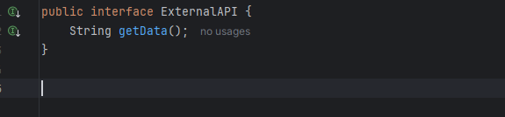

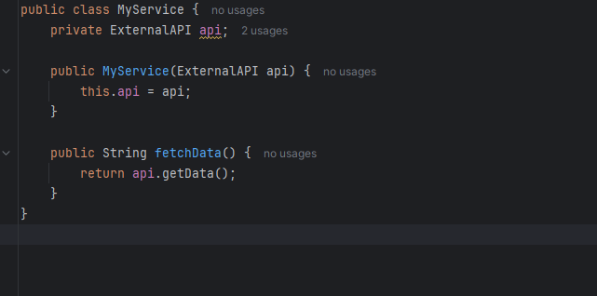

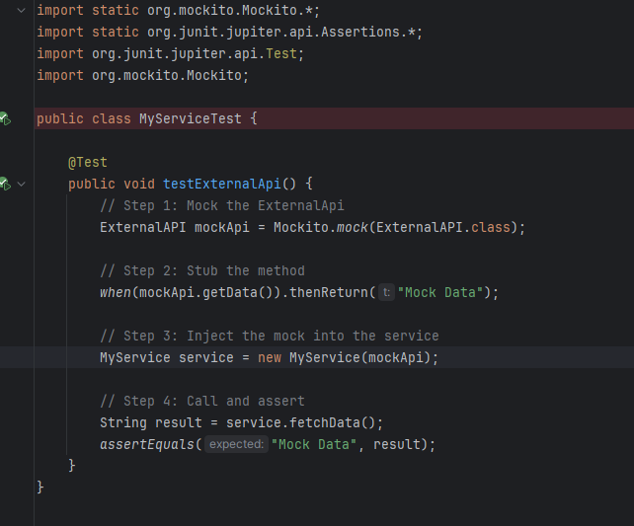

Output:

